**Your Business Card**

Your new business card will look like this:

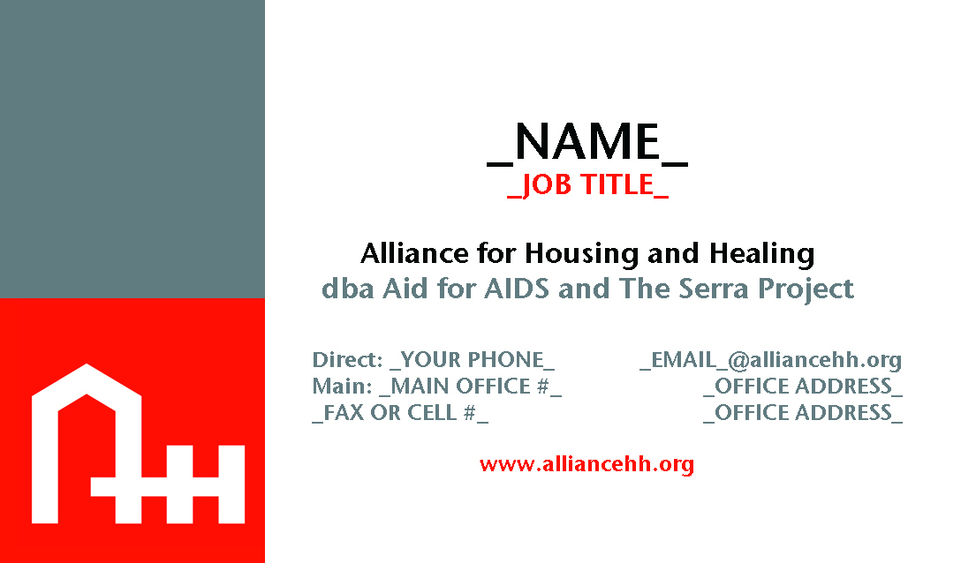

Please answer these questions to help complete the order for your cards and return this form to Cary at [cmonette@alliancehh.org](mailto:cmonette@alliancehh.org). Thank you.

Your Name:

Your Job Title:

Your Direct Phone Number (if you want this to appear on the card):

The Main Office Number (for the office or group home where you normally report to work):

Your Fax Number OR Cell Number (you can choose which to include on your card):

Your email address (Cary will work with you to migrate your address to one ending in alliancehh.org):

Your Office Address (for the office or group home where you normally report to work):

Additional comments: